The History of Coca –Cola
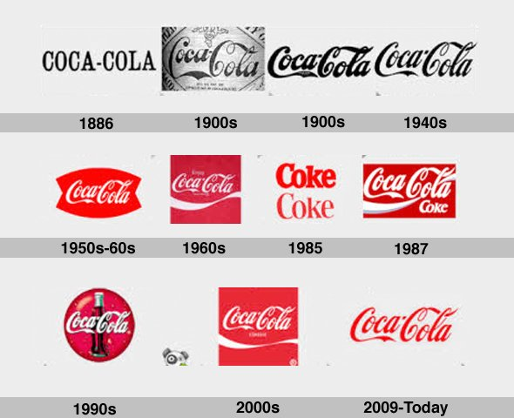

Website
By: Arthur Horn

I chose my topic because I thought it would be interesting because of the name Coke –Cola. I thought it would also be easier since Coke has so much information on it is almost endless. Another reason I chose Coke was because it is one of the all-time favorite soda brands and I personally think that it is the best cola tasting soda ever invented or made so far.
I conducted a lot of research online and read some books. They all said the maker or inventor of Coke-Cola was a man by the name (insert name here). He was the first one to invent the cola tasting product that we now know today as Coke-Cola.

